
Grocery Golden Market Phase II: Report (acp-confidential-cadoc)
December 2022 | Nithin Alexander Priya Gandhi Viraj Bindra Vanessa Li Research Brief

| Business Context & Research Questions: Several experiments were conducted in Q2 and Q3 to identify ways that we can improve perceived affordability of grocery shopping on DoorDash. Cost is a major barrier to entry for many Cx and perceived affordability is unique to each individual, based on their shopping context, socioeconomic status, and general expectations. The initial round of experiments indicated that a “flat fee” was the best approach. This new round of experimentation in Q4 is focused on finding the right flat fee and ensuring that Cx understand the fee and will therefore continue to use DoorDash.
This research is meant to help understand the current Cx perceptions of the flat fee including:
- Are Cx aware of the fee shown, do they understand it?
- Do Cx feel the fee amount provided is fair?
- How did the “flat fee” change their shopping behavior in the moment?
- How do they expect the “flat fee” to change their longer term DoorDash grocery shopping behaviors?
- What negative impact might the fee have on order frequency and/or perceived value?

| Designs for reference: FIGMA

Experiment Group | Fee Structure
Control | Existing Classic and DP fee structure
Treatment 1a | Classic: $7.99 Flat Fee  DP: $7.99 Flat Fee + 10% off subtotal up to $7.99
Treatment 1b | Classic: $5.99 Flat Fee  DP: $5.99 Flat Fee + 10% off subtotal up to $5.99
Treatment 2a | Classic: $9.99 Flat Fee  DP: $4.99 Flat Fee
Treatment 3 | Classic: $6.99 Flat Fee + $3 SOF on subtotal < $20  DP $3.99 Flat Fee + $3 SOF on subtotal < $20

| Research Approach & Sample:
We conducted a 10 min online survey with N=2245 respondents who visited DoorDash grocery during the time of the Golden Market experiments. The survey allowed for natural fallout of DashPass status, treatment shown and conversion.

- n=1718 converted, n=527 non-converts
- n=1530 DashPass, n=715 Classic
- n=714 treatment 1a, n=178 treatment 1b, n=616 treatment 2, n=733 treatment 3
- n=192 Cx that are “new to grocery”

| TLDR:
- The majority of Cx had a negative initial reaction to learning about the “flat fee” for grocery, driven by feeling DashPass has lost value, thinking it is an additional fee/they still have to pay service fees, or feeling upset that it is not longer valuable for small/quick shopping orders
  - Note some Cx indicated that while the fee is higher than expected it was still lower than the fees they pay for IC
- Cx that did convert were less likely to have a strict budget and more likely to already know about the flat fee
- Fees are too high/not worth the amount I was purchasing is the number one reason for non-conversion along with high item prices and overall subtotals being too high
  - There was no significant difference in ratings for “fees were not worth the amount I was purchasing” across treatments though 1b had the lowest percentage of non-converted Cx indicating this as the reason
- Cx who do understand flat fees see the value for high subtotals but the lack of value for low subtotals, they question if they will use DoorDash in the future for quick top off orders

| Recommendations:
- Consider revisiting tiered flat fees: Many Cx expressed frustration that they no longer had the opportunity to remove their fees by reaching a higher subtotal. Introducing a reduction in the flat fee over $100 may help to reduce this sentiment
- Provide a reduced flat fee for small orders for DashPass Cx: Many Cx called out that they are losing the value of their smaller orders by the introduction of the new flat fee. Create an option for a reduce fee for a small top off order, even if it can only be utilized once a month
- Include post order summaries: Many Cx are confused by the flat fee but will place their order “just this once” because of the circumstances of the moment. Make sure we provide a clear summary after the order is placed to educate Cx on the value for return trips. Flat fee education takes time, but we know that once Cx understand how and why it works they move from negative to neutral or positive sentiment towards the flat fee
- Show the flat fee later in the flow: Many Cx think flat fee is a new additional fee or a higher delivery fee, if they start a cart and learn at checkout, it may be an easier mental load because we can use strikethrough/cart prompts to communicate value

| Detailed Insights
Awareness of flat fees is a fairly high amount Cx with approximately two-thirds of Cx recalling seeing “flat fees” when they most recently visited DoorDash grocery. Cx who saw treatment 2 were the most likely to recall the offering, this likely because it was the highest flat fee amount shown to classic and second highest shown to DashPass.
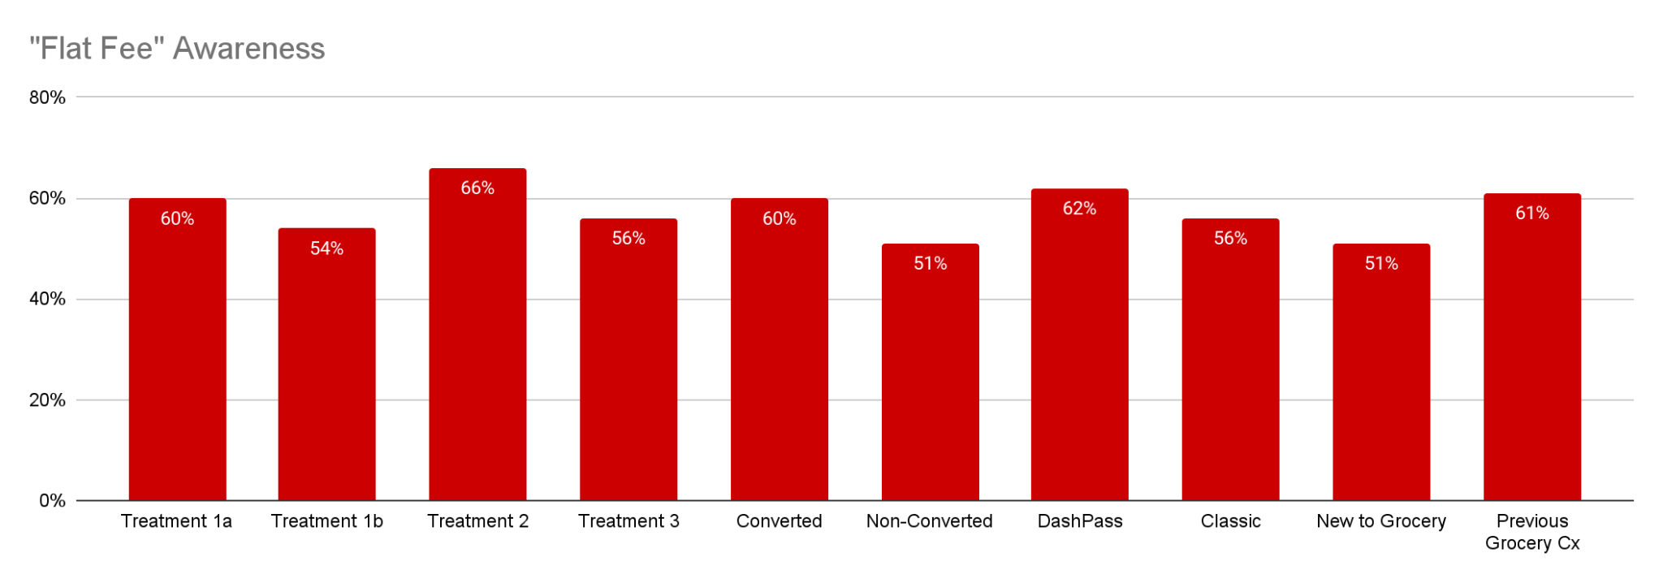
Only 26% of Cx indicated they felt the flat fee was very or somewhat fair. Most Cx have negative feelings towards the flat fee, drivers of sentiment can be found below. This is mostly driven by confusion around the fees. In qualitative interviews those who did not convert indicated they did not understand the fee or they thought it was an additional fee. Cx who did convert mentioned they took the time to click into different information sections to learn about how the fee works. Less than 10% of Cx (in all segments) indicated they are likely to use DoorDash to shop for groceries more as a result of the “flat fee”with approximately 40% of each Cx segment indicating it will not change the frequency of their grocery ordering. Some Cx indicated that they missed the previous opportunity they had to remove fees by reaching a particular subtotal amount.

Negative sentiment is driven by:
- DashPass Cx feeling they should not have to pay the “flat fee” along with their subscription fee
- Confusion around what the fee is/thought that it is a new additional fee
- Flat fee rate is too high (skews treatments 2 and 3)

Neutral sentiment is driven by:
- It feels fair for large orders but not smaller orders
- It took me a few times to understand how it works
- I don’t pay much attention to fees/I know I have to pay for convenience

Positive sentiment is drive by:
- Liking the idea of “no surprises”
- It’s easier/convenient
- It allowed me to order more

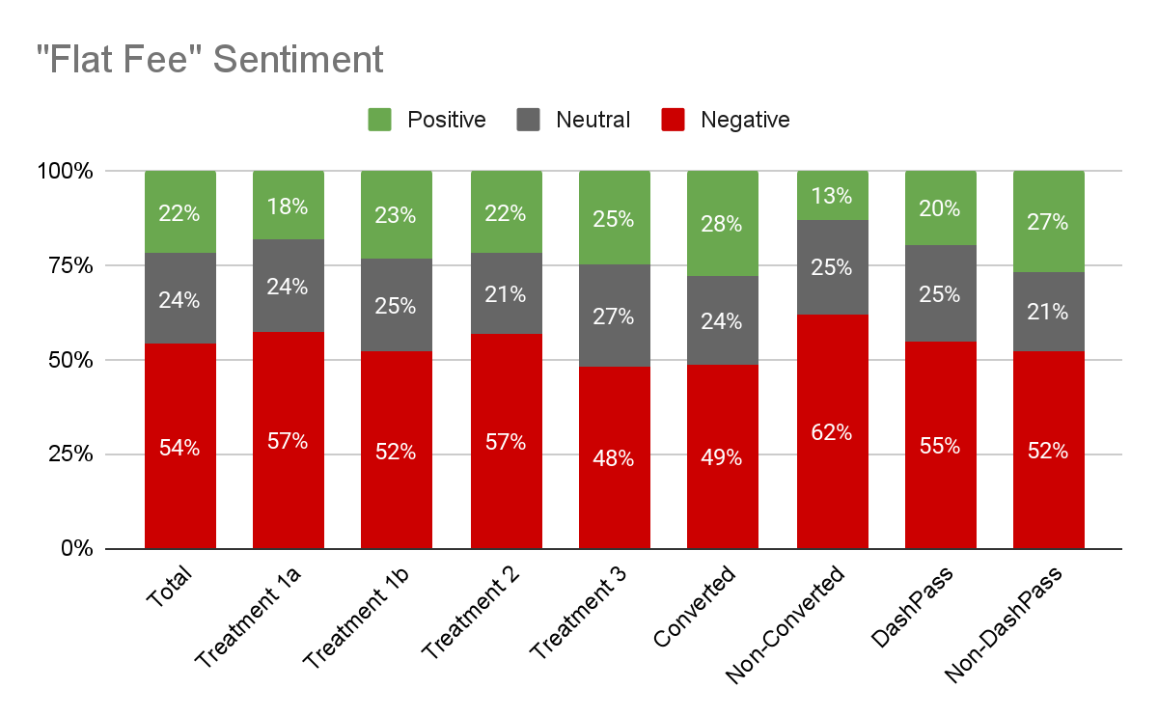
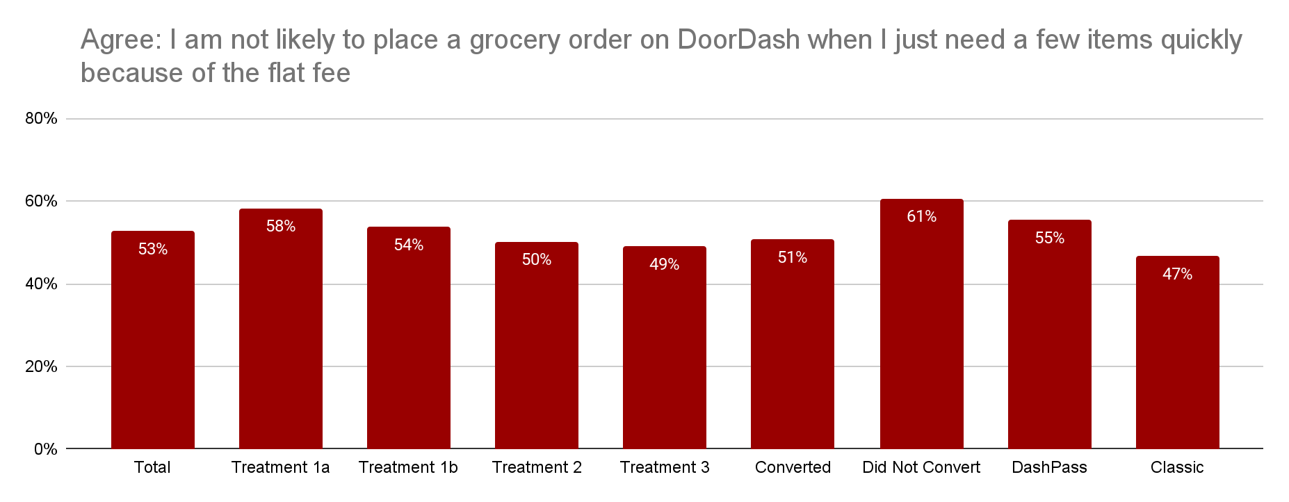
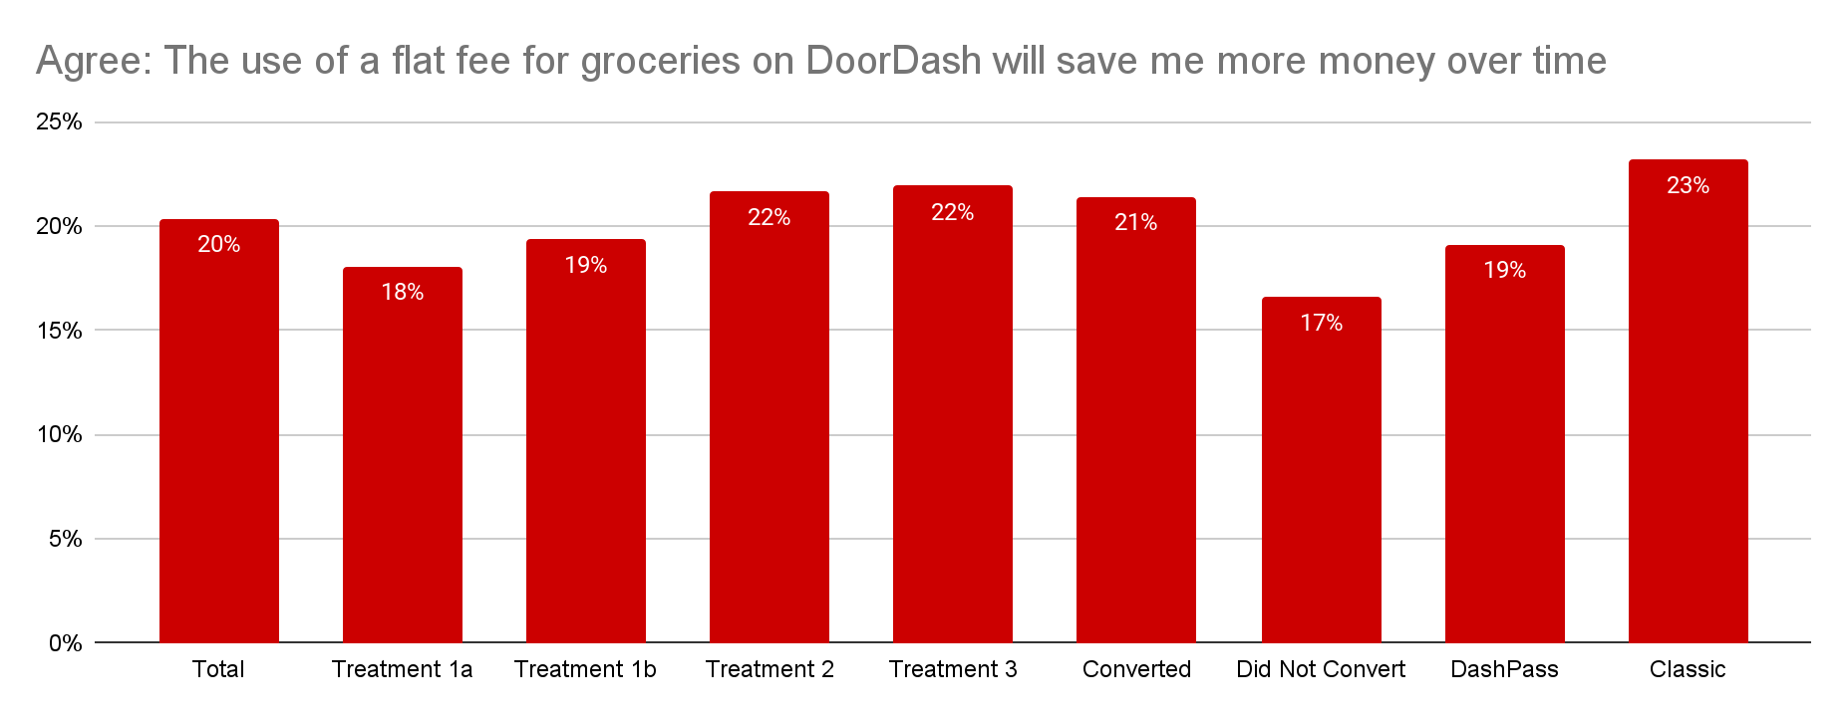
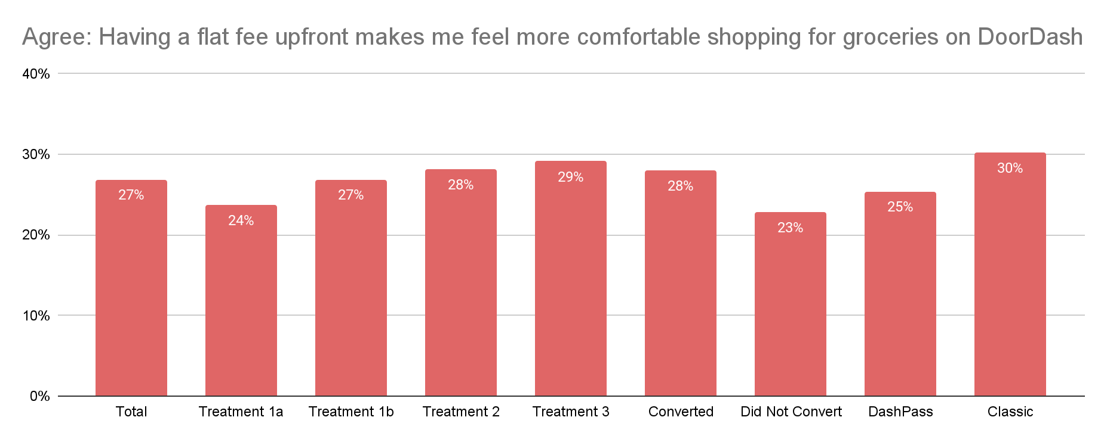

Only about a-third of Cx have a specific dollar budget in mind when starting an online grocery trip. Instead they have some idea of how much they will spend, which requires that we stick within a specific range. 44% of respondents who converted say they spent more than they had initially intended.
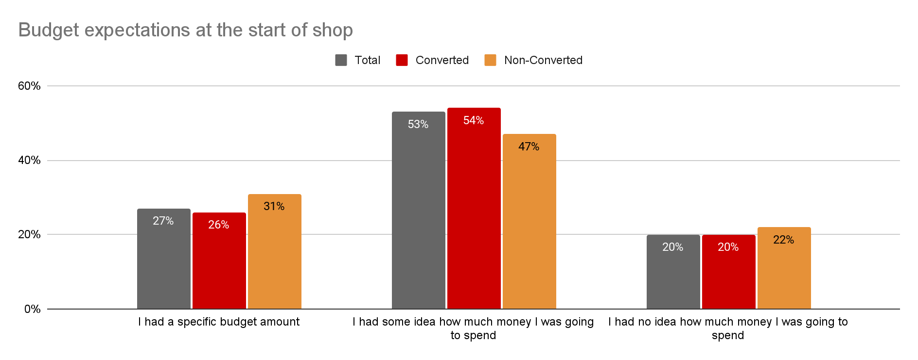Cx that converted were more likely to be shopping for a full weekly shop (21% vs. 11% non-converted) and to have a general list of what they are shopping for but not a set list of items ( 47% vs. 42% non-converted). Additionally Cx that converted were more likely to expect to pay a flat fee at checkout (21% vs. 16% non-converted) indicating that education of flat fees and how they work can help improve conversion/success rates. For Cx that did not convert, they indicated that fees, and the total among were not worth the amount of items they are purchasing. Additionally, one-third of Cx indicated that the items they were purchasing were too expensive, further reiterating the need to ensure we have consistent inflation caps across grocery items and stores.
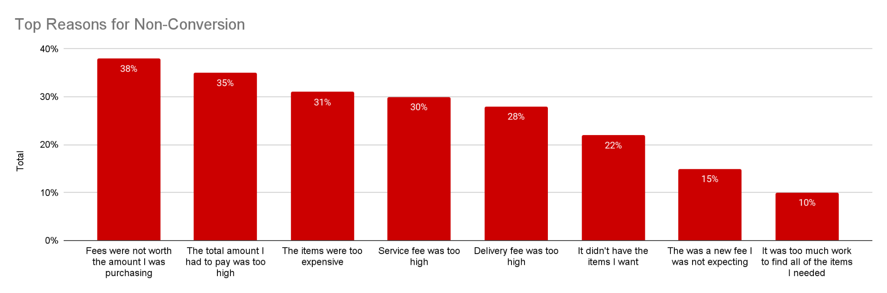

| Links
Link to full Data Tables
Link to Qual Tracker

